STRING Functional Enrichment Analysis of the tert Muscle Transcriptome

- Why this analysis? Aim?

The aim was to see what “common changes” show up when the differentially expressed genes (DEGs) are looked at as a group, and to cross-check the GRN results using a completely independent method. This is useful because the GRN model is built from CollecTRI, which only contains transcriptional relationships (transcription factor -> target gene). It cannot see other kinds of biology, such as proteins that physically bind each other. STRING is broader: it looks at how the whole set of genes is functionally connected, using many types of evidence. So STRING is a good way to (a) confirm the GRN findings from a different angle, and (b) pick up biology the GRN was blind to.

- About STRING

STRING (Search Tool for the Retrieval of Interacting Genes/Proteins) is an online database of known and predicted protein–protein associations. For each pair of proteins it combines several kinds of evidence: laboratory experiments, co-expression, shared pathways in curated databases, and automatic text-mining of the literature into a single confidence score. For this project the important feature is STRING’s functional enrichment analysis. Given a list of genes, STRING asks: “are any biological pathways, GO terms or diseases over-represented in this list compared to what you’d expect by chance?” This tells you what the gene list is about as a group, instead of looking at genes one at a time.

- Inputs to STRING

Input gene lists: string_input_human_symbols.txt (pooled), string_input_DOWN_in_MUT_human.txt, string_input_UP_in_MUT_human.txt

The starting point was the Q1 (genotype) DEG list – the genes significantly different between mutants and wild-type at 18 months (q < 0.05 and |log2 fold change| > 1). This gave 5,541 DEGs (4,252 down and 1,289 up in mutants).
Because human STRING is much better annotated than zebrafish and because the GRN was also built on human orthologues, the zebrafish DEGs were mapped to their human equivalents using g:Profiler (g:Orth) before running STRING. Mapping is lossy (zebrafish underwent a whole-genome duplication, so not every gene has a clean one-to-one human match), so the final input lists are a little smaller than the DEG counts.

STRING was run three times:

Run | Genes going in (human symbols) | Question it answers
All DEGs (pooled) | 3,698 | the overall picture
Down in mutants | 2,879 | what is switched OFF
Up in mutants | 917 | what is switched ON

STRING settings: organism = Homo sapiens; statistical background = whole genome; standard confidence. (The interactive network picture is switched off automatically for large lists. That is normal and does not affect the enrichment results.)

- Methodology

- Took the Q1 DEG results table and kept the significant genes (q < 0.05, |log2FC| > 1).
- Split them into “up in mutant” and “down in mutant” sets.
- Mapped each set from zebrafish to human symbols with g:Profiler.
- Pasted each list into STRING’s “Multiple proteins” search, organism = Homo sapiens.
- Let STRING build the network and compute functional enrichment.
- Exported the results: the full enrichment table (“all enriched terms”, tab-separated) and the Biological Process enrichment plot for each run.
- Cross-referenced the enriched terms and their member genes against the GRN’s TF-target lists (done in Python).

- Outputs

The enrichment tables:
enrichment_all.tsv, enrichment_all_down.tsv, enrichment_all_up.tsv.

Each run produced a table where every row is one enriched term (a GO term, a KEGG [4]/Reactome [5]/WikiPathways pathway [6], a disease, etc.). The key columns are:
- count in network: how many of the genes fall in that term.
- strength: how strongly the term is over-represented (higher = more concentrated in list).
- signal: STRING’s combined score of strength and significance, used for ranking.
- false discovery rate (FDR): the significance after multiple-testing correction. Smaller = more reliable; below 0.05 is significant, and the top terms here are far smaller (e.g. 1e−31).
- matching genes: the list of genes in that term (used for the cross-check with the GRN).

The enrichment plots:
STRING also draws a Biological Process plot for each run (Figures 1–3). In these plots each row is an enriched process; the dot position (Signal) shows how strong it is, the dot size shows how many genes are involved, and the colour shows the FDR (greener = more significant). They are a quick visual summary of the same information in the tables.

Figure 1: This plot shows the top enriched Biological Process (GO) terms [3] when all 5,541 differentially expressed genes are analysed together, without splitting by direction. The processes that come out on top are cell-cycle terms (meiotic cell cycle, nuclear division, cell cycle process, DNA replication) mixed with cilium terms (cilium organization and assembly). What we interpret from this is that the dominant change in the mutant muscle is something to do with cell division and DNA replication but because up- and down-regulated genes are pooled together, and roughly 77% of the DEGs are down-regulated, this pooled view is dominated by the down genes and effectively hides whatever the up-regulated genes are doing.

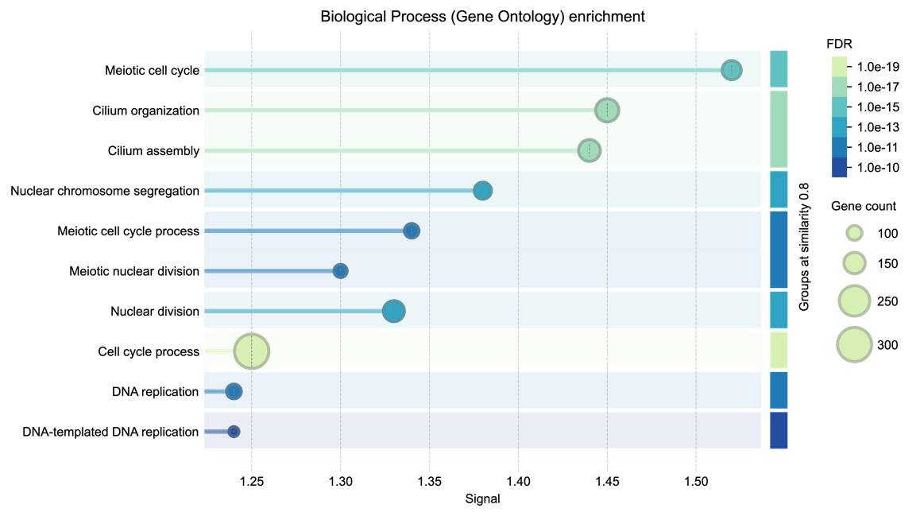
Figure 1. All DEGs pooled together. Cell-cycle and cilium terms dominate, but because the up and down genes are mixed, the picture is blurred.
Figure 2: This is the same type of plot, but run only on the genes that are down in mutants (2,879 human-mapped genes). The result is the same cell-cycle/DNA-replication theme as Figure 1 but much sharper, i.e., the significance is far stronger once the up genes are no longer diluting the signal. The top processes are meiotic and mitotic cell cycle, nuclear/chromosome division, and DNA replication, alongside cilium assembly (which shares the same microtubule machinery as the mitotic spindle, so it rides along with this group). This is a clear proliferation shutdown: the cell-division and DNA-copying machinery is being switched off in mutant muscle. This is the direct, independent confirmation of the GRN result, where the E2F transcription factors (whose entire job is driving these exact genes) were the most strongly repressed.

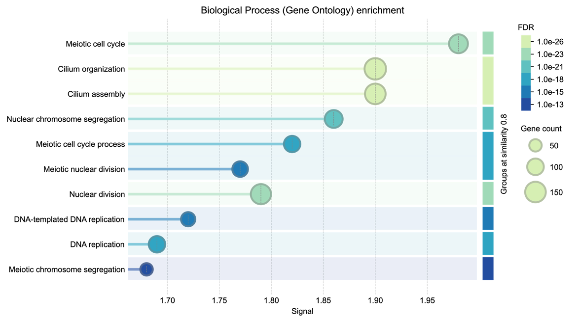
Figure 2. Down-in-mutant genes. The signal is much stronger and cleaner: cell cycle, nuclear division and DNA replication: the proliferation machinery being switched off.

Figure 3: This plot runs only on the genes that are up in mutants (917 human-mapped genes), and it reveals a completely different biological story that was invisible in the pooled Figure 1. Instead of cell cycle, the enriched processes are all about tissue structure and remodelling: extracellular matrix organization, muscle structure development, striated-muscle and muscle-cell differentiation, myofibril and sarcomere organization, and muscle contraction. This is an active tissue-remodelling and stress response: the mutant muscle is rebuilding its extracellular scaffolding and altering its contractile/structural components. Combined with the stress, immune and inflammation terms that also appear in the up-set (in the full tables), this is exactly the secretory/remodelling side of a senescence phenotype.

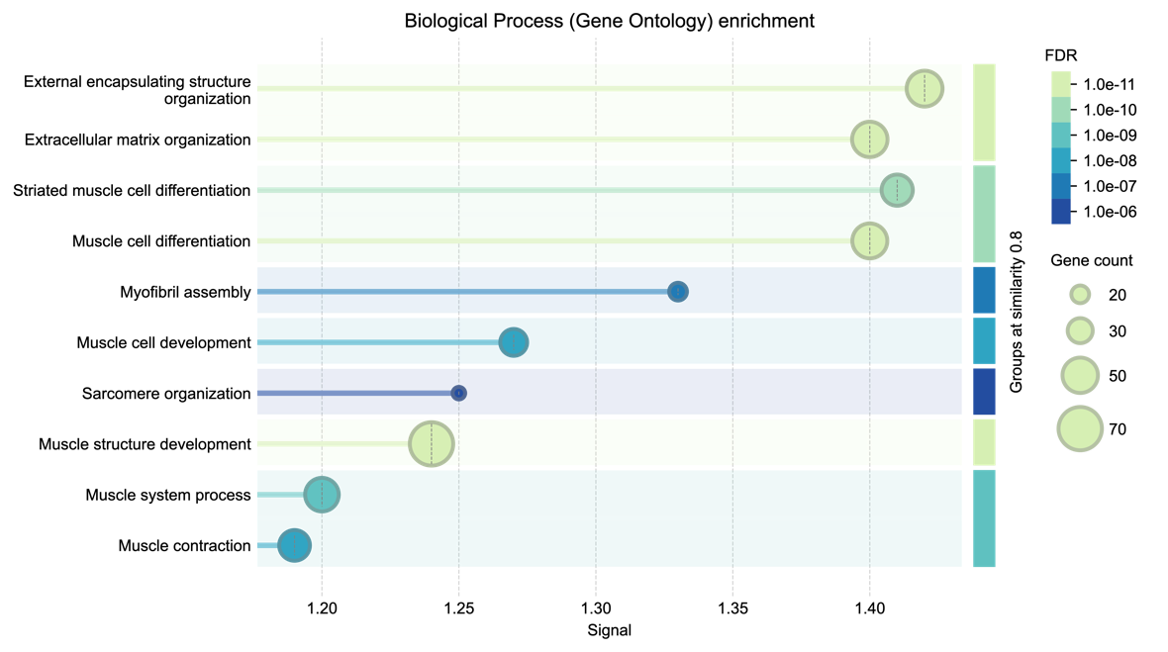
Figure 3. Up-in-mutant genes. A completely different set of processes: muscle structure, extracellular matrix and sarcomere organisation: tissue remodelling.

- Results Explanation

The pooled run:
When all 5,541 DEGs went in together, the strongest enriched terms were cell cycle / DNA replication and cilium/microtubule organisation (Figure 1; Reactome “Cell Cycle” FDR 2e−19). This looked interesting, but pooling has a problem: most DEGs (4,252 of 5,541) are down in mutants, so the pooled result mostly reflects the down genes and the up-gene signal is drowned out.
Splitting up and down:
To fix this I ran the up and down sets separately. This sharpened everything, and the FDRs actually got stronger because each signal was no longer diluted by the other.

Down in mutants (2,879 genes): the proliferation shutdown. Overwhelmingly cell cycle, mitosis and DNA replication (Reactome “Cell Cycle” FDR 4.9e−31; GO “Cell cycle” FDR 4e−34; KEGG cell cycle, DNA replication, Fanconi anaemia; WikiPathways “Retinoblastoma gene in cancer”). The cilium/microtubule terms sit here too, which makes sense because they share the same microtubule machinery as the mitotic spindle.

Up in mutants (917 genes): tissue remodelling and stress. A completely different programme: extracellular matrix and collagen remodelling (Reactome “ECM organization” FDR 2e−13), muscle-structure and sarcomere terms, and stress/immune/inflammation terms (cytokines, immune system process, inflammatory response), plus muscle-disease/myopathy terms that fit the flank-muscle tissue.

Cross-check with GRN:
The two methods agree, right down to the individual genes:
- Of the 248 genes in STRING’s down “Cell Cycle” term, 65 are targets of the GRN’s repressed TFs and all 65 are E2F targets. So the genes STRING flags as “cell cycle, switched off” are the same genes the GRN said “E2F stopped driving.”
- On the up side, of the 497 genes in “Response to stimulus,” 252 are targets of the GRN’s activated TFs and 62 are TP53 targets. So the up programme lines up with the AP1/TP53/NFKB activated pole of the GRN.

This is strong because the two methods use completely different inputs (STRING = protein associations and literature; GRN = curated TF -> target rules). When they land on the same genes and the same directions, the result is much more convincing than either alone.

- Summary

Put simply, both methods tell the same story: in tert−/− mutant muscle the cell-division machinery is switched off (E2F / cell cycle down) while a stress, remodelling and inflammation programme is switched on (TP53 / AP1 up). This “stop dividing + stress response” pattern is what we’d expect from cells entering senescence, and fits the apoptosis-to-senescence switch described for this model. The STRING analysis independently backs up the GRN and adds the tissue-level remodelling picture that the GRN could not show.

- Limitations

- The zebrafish to human mapping is lossy: about a third of the DEGs did not map to a human orthologue, so those genes are not represented.
- STRING enrichment does not know direction by itself. I imposed the up/down split manually, which is why the separate runs are more meaningful than the pooled one.
- The analysis used a whole-genome background. A stricter option is to use only the genes actually expressed/testable in my experiment as the background; this can be added if needed.
- Enrichment shows association, not causation. It says which processes are over-represented, not that telomerase loss directly causes each one.

- References

[1] D. Szklarczyk, R. Kirsch, M. Koutrouli, et al., "The STRING database in 2023: protein–protein association networks and functional enrichment analyses for any sequenced genome of interest", Nucleic Acids Research, vol. 51, no. D1, pp. D638–D646, 2023.
[2] U. Raudvere, L. Kolberg, I. Kuzmin, et al., "g:Profiler: a web server for functional enrichment analysis and conversions of gene lists (2019 update)", Nucleic Acids Research, vol. 47, no. W1, pp. W191–W198, 2019.
[3] The Gene Ontology Consortium, "The Gene Ontology knowledgebase in 2023", Genetics, vol. 224, no. 1, iyad031, 2023.
[4] M. Kanehisa and S. Goto, "KEGG: Kyoto Encyclopedia of Genes and Genomes", Nucleic Acids Research, vol. 28, no. 1, pp. 27–30, 2000.
[5] M. Gillespie, B. Jassal, R. Stephan, et al., "The Reactome pathway knowledgebase 2022", Nucleic Acids Research, vol. 50, no. D1, pp. D687–D692, 2022.
[6] M. Martens, A. Ammar, A. Riutta, et al., "WikiPathways: connecting communities", Nucleic Acids Research, vol. 49, no. D1, pp. D613–D621, 2021.

